Choose one object now in a museum. Describe, analyse and discuss the object’s biography and social life since its production.

In this essay, I will study an object’s life under the prism of its social, cultural, financial and religious effects on the people. By choosing the Icon of Annunciation from the Orthodox Christian tradition, I will prove that not only objects in the museums require attention of observation and admiration but also objects with personality are capable to define their own destiny, regardless the place and time they ‘live’. Observing through the different step of object’s lifecycle, I will present the facts how any object can influence people’s beliefs, lifestyles, environment and way of thinking. The essay gradually focuses on the icon by going through the general concept of objects’ life and their impact on the society in a Material Culture.
“Material Culture” is term used for ‘thing’, ‘specimen’, ‘artecraft’, ‘good’, and object collectively. But every object, thing, good or artecraft shows us entirely different world of knowledge depending upon the tradition of study. Material Culture is a broaden frame that covers almost everything from a plant to a song. “Material Culture is that segment of man’s physical environment which is purposely shaped by him according to a culturally dedicated plan” If explained otherwise, material culture covers whole cultural expression, one way or another. It is primarily a cultural value that makes an object a ‘moveable piece’ and how and with what process was used to create or form that object becomes secondary or most of the times remains irrelevant.
To understand more about objects we may look at Pearce, defining the object in the following text: “Objects are lumps of the material world. They share this nature with all living things, including ourselves, and this materiality distinguishes all that share it from insubstantial creations like tunes, poems, or the idea of marriage. Like ourselves, objects can only be in one place at any given time.” Objects ‘live’ life like us and may have longer lifespan with complex lifecycles. Pearce gives an example of typical lifecycle. “Objects can have complicated life cycles in which part of their time is passed in enjoying some kind of regard, part as garbage or semi-garbage in discard dumps or junk heaps, and part resurrected by archaeological processes or by shifts in taste, to be reinstated in museum collections and the like. Ultimately, however, they die, suddenly in accident, war or act of God, or gradually through the slow processes of decay.”
Objects carry information about their time, space and significance they bear at that particular time. Objects enjoy great significance and importance in the society and this ‘translates’ the society’s own individuality of thoughts and culture. As Janet Hoskins narrates in the following quotation: “But the use of an icon, a concrete vehicle for our thoughts, is of course common across the divide of cultural differences.” Objects, in cultural prospective, are the commodities that are not only produced materially but also culturally marked as being certain kind of things. The same thing or object can be considered as commodity at one time and not at another.
Icons are the objects with special meanings and characteristics in Orthodox Christian tradition. The word ‘icon’ has number of meanings in art history, art criticism, linguistic and semiotics. Some authors used the Greek word ‘eikon’ or ‘ikon’ to indicate the specific meaning it belongs to. “The Greek word eikon can be translated as ‘image, picture, portrait, representation’. The modern use of the word denotes two-dimensional representations such as paintings, photographs, or pictures in magazines and newspapers, and three-dimensional objects such as statues. In certain contexts the word refers particularly to pictures, are regarded by members of the Orthodox Christian Church as sacramental. An Icon is a mysterion, a sacred mystery, a sacrament. It is sacramental in two senses, being both a result and a means of consecration.” Icon, as mentioned above, is physical object painting on wood, which can be carried around. The icon could be an image of a holy person or a seen from the holy writings or both. Icons composition reflects the relationship of the created world to its Creator.
A representative paradigm which shows the power that an icon has over the religious people is the Annunciation’s icon in Tinos Island in Greece.(Fig. 3) The reason that makes this icon so unique is how it came into our possession. On 9th July 1822 a nun called Pelagia from the Kechrovouniou Monastery on Tinos, had a vision. She dreamt of the Holy Virgin. She gave her specific instructions on where she should dig in order to discover her home and her icon otherwise the island would be infected by cholera. Because she was so humble to believe that the Holy Virgin ‘visited’ her in her dream, she didn’t follow Holly Virgin’s orders. But the dreams continued. After the third vision and under Sister Pelagia’s guidance, the local inhabitants started excavations. Two months later the only thing that they had discovered was the remains of a Palaiochristianic church of Saint John which had been burnt down by Sarakin Pirates in 1200 A.D. Finally they abandoned their efforts and the cholera spread like wild fire over the island. This was strong evidence that they should continue digging devotedly and on 30th January 1823 they brought the icon of the Annunciation of Mother of God to the light. After the Megalochari icon was found, the islanders decided to build a large church. Marble columns from the ancient temples of Delos and Poseidon at Kionia (on Tinos) were used in the construction, as was local marble from the quarries of Panormos. The news of the icon’s discovery spread quickly through Greece, and almost every ship passing Tinos with a load of lime, timber, or other building materials docked there to donate part of its cargo to the construction effort. Volunteer workers came from distant parts of Greece. All the population of the island helped. Wealthy and poor, lords and loon, local and foreigners, women and children were working day and night with zeal and enthusiasm. The construction of the church was sponsored by rich people who were giving their money and jewelery and by poor people who worked voluntarily. Even the women and the children were helping by transferring building materials.
The Greek nation was so devoted and so passionate about the building of the temple, which would be the ‘home’ of the Holy Icon, that not only the indigenous but also people from all around Greece and abroad; wherever Hellenism existed. The most impressive thing was that the temple was ready in a year. With pure “Aegean” expression the two floor building is influenced by the Byzantine temples of Constantinople and by the Post-Byzantine Cycladic churches. Beyond the monasteric structure of the temple there was a great contribution of artists who ‘perked up’ the building complex and they ‘infused’ Tinos with a new identity: from the Island of Faith it became also Island of Art. (Fig. 7) In 1984 A. Nicolas (a Greek Cypriot) translated and published some articles of newspapers during the period 1842-1885 which were related to Greece and especially to Tinos. Among others he says: ‘While we are approaching Tinos the most magnificent spectacle is the famous temple of Panagia. It is made of marble and because of its snow-white colour is shining. The monastery, the yards, the gardens and the main bell-tower, which has 130 feet height, take up a lot of space… After Holy Places and the Athos, the church of Holy Mary is the temple that Greek people respect the most. Every year a mass of pilgrims gather from all around the world and there are numerous of narrations about miracles that achieved with the ‘help’ of Holy Mary. The main entrance, the yards and the loggias all around have familiar style with Mosques of Constantinople, which all of them have of course Hagia Sophia as a prototype. The church is full of precious offerings. From the centre of the painted dome a huge pure silver chandelier is hanging and innumerous small lamps of the same valuable material are all around’.
The icon, that was found, was the Annunciation. Although the shovel of the worker cut the icon into two pieces, the forms of Archangel Gabriel and Holy Mary were sustained untouched. The backside of the icon is burned. The main hypothesis is that the icon was kept initially in the Palaiochristianic church of Saint John which was burned (part of the foundation can be seen in the basement of the church). Thanks to humidity the icon was preserved until 1823. The gold and valuable stones, offerings by pilgrims, cover the mark that was provoked by the shovel. On the first pilgrimage, the duchesses of Tinos put every precious thing they had with them on the mark in order to cover it.(Fig. 1)
In the copy of the icon that is kept in the vestry of Holy Foundation the Megalochari is presented praying on her knees with head bowed. She is wearing a long colored dress (golden, yellow, green), standing in front of small and short lectern, where each surface is covered with golden and yellow fabric. The neckwear is tied up in the same way the daughters of Nazaret were wearing. The words that are mumbled by Panagia after the Annunciation are written in the book that is placed on the lectern: “IDOU I DOULI SOU KYRIOU GENOITO MOI KATA TO RIMA SOU.” Deep inside the room we see windows on both sidewalls and top middle of the icon we can see the Holy Spirit with appearance of a pigeon in a shaft of light. In front of the virgin Marry facing her with the same colored dress, the Archangel Gabriel stands gleaming and full of spirit holding a lily in his left hand, which symbolizes virginity. (Fig. 2)
“Some historians date this icon to a period earlier than Byzantium, possibly the first half of second century of Christianity.” Many of the scholars who had studied the icon classified it among the first three works of Evangelist Lucas. Moreover they claim that wonder-working hypostasis derives from the blessing of the Holy Marry. On the other hand, many others argue that “this is considered to be only a pious hope of local Christians; it was not stated by the Mother of God during her appearances to sister Pelagia, nor are there any other clues to the icon’s origin. Nevertheless it is wonder-working icon, and since its discovery thousands of verified miracles have been reported by those who have prayed before it for the intercession of the Mother of God.”
Despite the turbulent past of the icon, it had eventful future. “Sadly, in 15th of December, 1842 the icon was stolen by Christodoulos Dimitriadis, a young Greek criminal passing through Tinos. As it is today the icon was then covered with golden precious stones given in thanksgiving for answered prayers. Dimitriadis hid in one of the overhanging balconies, waiting for the church to close. After dark he lowered himself by a rope and fled with the chalice, altar utensils, and the wonder-working icon. When the loss was discovered the following morning, church bells tolled mournfully throughout the island, announcing the theft. Patrols were organized in all the villages and Dimitriadis was caught at noon, trying to escape with his stolen goods across the narrow straits separating Tinos and Andros. The recovery of the icon was a cause of general Rejoicing and the Megalochari was triumphantly returned to its place in the Cathedral.”
The icon of Annunciation is appreciated with love, worship and reputation just because of one reason, the Miracle. The Miracle that made Tinos a symbol. The Miracle that, people believe, comforts and makes promises. The reactions of the pilgrims can even reach the edges. They, in their ecstasy, lie on their knees, pray with tears and ache for their own salvation. The pilgrimage in Panagia of Tinos and the faith in the icon’s miracles are not only the poor people’s ‘privilege’. The impressive offerings and jewelry declare the deep devotion to Panagia from the wealthy also. The phasma of offerings, from the most humble to the most precious, shows that the church attracts the believers from every corner of the world regardless their religious beliefs, age, gender, ethnicity and social background.
Since the discovery of the icon innumerous and renowned miracles have been recorded. It is crucial to refer to the few characteristic miracles that have been recorded in order to understand the charismatic power of the icon. The most famous of the tamata, which can be unnoticed from the visitors, is “a model of a ship made of gold and silver with a fish hanging out of the breech. Around the mid-1850s, a ship sailing in the Mediterranean, met with the cyclone. The ship’s crew struggled to keep the vessel afloat, but the stormy waves forced a breach in the hold and the ship begun to sink. Bailing and pumping, the frantic crew prayed fervently to the Mother of God and finally managed to sail the listing ship to harbor. As they begun to repair the damage caused by the storm, they found to their amazement that a huge fish has swum into the breach of the ship and was trapped so tightly that it had stopped the influx of water. The crew immediately saw the hand of the Mother of God in this and in thanksgiving sent the church this model”(Fig. 4)
Another well known votive offering is a silver orange tree with the hanging vigil candles from its branches. “A Greek-American lost his sight after a serious illness. He had heard about the miracles performed for people who prayed before the icon ‘of Great Joy’ and begged to Mother of God to restore his sight, promising to offer her the first thing he saw. God’s grace manifested the virgin’s prayers, and when he regained his sight, the first thing he saw was a beautiful orange tree. The meticulously crafted miniature of the tree can be seen to the right of main doors of the church of the Annunciation.”(Fig. 5)
“It is not only among the orthodox that God’s grace acts for those who pray to Virgin. In the 19th century, a Turkish mοslem colonel who suffered from an incurable disease visited the icon and asked the prayers of the Mother of God. He was healed and out of gratitude constructed the marble fountain near the staircase leading to the church. The water in this fountain is blessed every year on Theophany.” Because the main character of this story was Turkish and because the majority of recent Greek state was extracted from Turkey, this story attains special meaning as recognition of Panagia’s Icon’s power (for Orthodoxy and Greek nation in general).
The faith in Megalochari of Tinos enforced and set its roots up with miracles and with the verification of the words of Evangelistria. It reminds us the miracles of Christ and the confirmative of his words which enforced the faith into Him and the Christianity. Millions of pilgrims have testified their entreaty, blessing, happiness, hope, pain, cry and the Tama for a miracle, devotionally to Her. The diachronic attraction of Megalochari to Her pilgrims is illuminated by their countless offerings to the icon, in the temples of ‘Evresi’ and ‘Evangelistria’. The overwhelming religious feelings of the pilgrims, that could be seen through the offerings from ‘two cents of widow’ to priceless diamonds, provide, in parallel, the valuable historical validation to the very complicated and diachronic of Megalochari; the Annunciation.(Fig. 6)
The discovery of the icon of Megalochari in Tinos Island, on 30th January, 1823 was a determinative fact for the reborned Greek state. The Pelagia’s vision ‘came’ in a very crucial moment of the Greek history because almost one year before that vision the Independence war had started. The finding of the Holy Icon was an omen of the Holy acquiescence to the titanic strangle. The Greek Revolution had begun on 25th of March, 1821, the anniversary of Annunciation. After four hundred years of Turkish occupancy the Greek revolutionists chose that day to start their resistance. Since then this day is celebrated in Greece with dual importance. In other words, this day combines two rebirths: the humanity and the Greeks. The finding of the Holy icon includes also the idea of resurrection. The history is repeated, as it happens in the history of Annunciation, a Holy being, Panagia, talks to a virgin, the old and moral sister Pelagia. The virgin Pelagia becomes the body of the rebirth of Greek nation according to the symbolism of the finding of the Holy Icon, such as Holy Marry became the carrier for the humanity’s renaissance. Moreover the icon which used to be accommodated in Byzantine temple was buried due to pillages of the barbarians. For all the aforementioned, the Panagia of Tinos and Her miraculous icon acquired important national and universal diastasis and transformed into a center of attraction for the Orthodox of all around the world.
Evangelistria was the ‘Prostate God’ of Revolution, the faith which had predetermined its success. The enslaved Greek nation based its hopes for freedom on Her, it strongly believed that Panagia would protected its struggle and that She would guarantee the positive outcome of the war. She ‘kept Her promise’ and for that reason, after the foundation of the first Greek State in 1832, many participants of the War felt obliged to go to Tinos and pay their honours to Her Grace. Among the first pilgrims were Konstantinos Kanaris, Miaoulis, Karaiskakis, Makrigiannis, Kolokotronis and many others. Panagia was always considered to be a national symbol. Until 1922, when The Catastrophe of Asia Minor and the Separation of the eastern part of Greece by the Turkey happened, the temple epitomised the main patriotic and religious index mark. This was very obvious especially in the days of temple’s celebrations: Icon’s Finding day (30 January), Annunciation’s day (25 March), Saint Pelagias day (23 July) and Dormition (15 Augoust), when the island was flooded with a vast concourse of prayers and with an atmosphere of emotive manifestations of national elan. From the day of Icon’s Finding until now, political personages, Kings, Presidents of Democracy, Prime Ministers, Cabinet Ministers and several other representatives of the State come along not only to revere but also to express their gratefulness to the Guardian of the Nation.
Another characteristic paradigm, which empowers the belief that the icon has been the guardian angel of the Hellenism, is the torpedo of the war craft ‘ELLI’. The ship was moored in the port of Tinos in order to do honours to the Megalochari’s celebration on 15th August 1940. It was considered as a miracle because thousands of people were saved by definite death. Panagia of Tinos was regarded to protect the Greek army in the Albanian War, led it into a triumph and saved the Greek Nation. In December of the same year Panagia of Tinos, through its Foundation, had a great contribution in the needs of war and generally in the salvation of Greece. The Foundation disposed temples and Holy Icon’s valuables and the jewellery. In the 20th March, 1945, when the Anniversary of National Independence was celebrated for the first time, the government ordered the transportation of the Holy Icon with all the proper honours in the capital of Greece, Athens, so as to enlighten the celebration and to enable every citizen to express his adoration and his thanksgivings towards the Patron of the nation.
Before analysing the general contribution of the Panellenic Holy Foundation of Evagelistria of Tinos, it is important to mention the financial section. The pilgrimage is supposed to be a major perspective. Apart from the wealth that is in the church’s disposal, part of which returns to the locals as charity, a big amount of people, who live there, are depended, directly or indirectly, on the pilgrimage to cover their expenses. The pilgrims rent rooms, eat in restaurants, buy local goods and souvenirs, tickets for the buses and the ships, and play, in general, an important role in the island’s economy giving rise to the domestic agriculture and establishing new work positions for the natives. The major part of local businesses is providing services to the pilgrims and most of them are completely depended on that.
The Holy Foundation of Evagelistria has a national, religious, educational, charitable, social activity which can be considered as exemplary for every typical foundation. The administration of the Foundation contributed radically in the field of education, art, culture and in several beneficial activities. Tinos managed to have educational system in really tough periods for the Hellenism (Independence War: 1821-1823, Kapodistrian period: 1828-1831, Othonian period: 1833-1862), which was considered to be a major achievement. Since 1823, the potentates of Tinos had established a school in church’s yard in their own expenses. This was only the beginning. The Foundation supported opening of many more schools after that; it also offered huge amount of money (in comparison to the financial reality of that time) for the buildings, conservation of schools, hiring and payments of teachers, buying books etc. The phileducational action of the foundation continues since then.
But the Foundation’s cultural and social presence extends in many other sections beyond education. In the yard of the temple, the owners established a remarkable library with old and rare publishing and also archaeological collection in 1824. This initial effort developed into the contemporary impressive and valuable museums which can be visited in the monastery and in the Centre of Tinos. Furthermore the committees have never stopped establishing and conserving charitable institutes and schools (Music School, Silk Textile Industry School, Biotechnical School, High School, School of Fine Art of Panormos, Holy Icon Paintings School, and School of Byzantine Music). They also continued supporting missions, monasteries, orphanages, higher and technical education institutes (e.g. University of Athens in 1833) and, later in 1840, they started scholarships for outstanding artists, painters, sculptors such as Nik. Gyzis, Nik. Lytras, Gian. Chalepas and many others. In addition, they funded to construct infrastructure for the island (port, roads, water supply, electricity etc.). They extended their support for the battles of the nation, armada and to help refugees of Crete and Asia Minor. All the aforementioned where achieved with the money derived from the pain, the faith and the hope of humble and stormed people.
All the above mentioned facts underline the divergence of another ever happening miracle in Tinos island; that composed the multiform activity of the Institute - national, religious, educational, charitable and social - that surrounds not only Greece but also the Greeks all over the world. The Holy Virgin’s Icon’s Finding was a crucial point for the island. It upgraded it mentally and financially, it transformed it into a centre of pilgrimage and in the recent Greek history, Tinos was recorded as “the Panagia’s Island”. This Icon is a representative example of an object outside of museum which had earned the glory and fame on its own. Not only it had earned the religious respect by a nation but also it had ‘paid back’ by supporting, giving hopes, encouraging and inspiring it. Although the creator had just paid honour to a religious miracle by this Icon, the objects chose its destiny and became a miracle by itself.

Bibliography

(The bibliography is missing for logical reasons.)

APPENDICES

Fig. 1: The Annunciation Icon with the jewelry in the Temple of Evengelismos in Tinos.
(McLees, Mother Nectaria, ‘The Tinos Icon of Great Joy’, Road to Emmaus, 10 (Summer 2002), Portland, USA. http://www.roadtoemmaus.net)

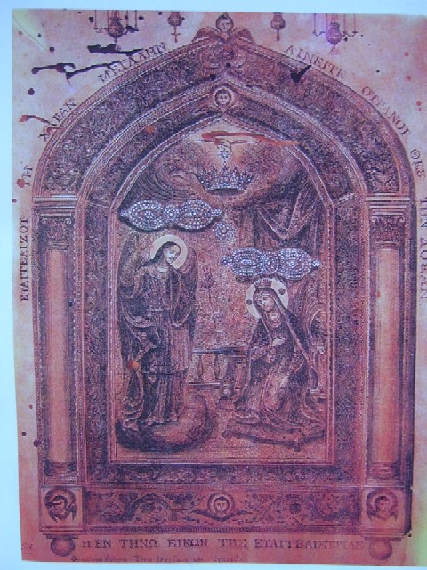
Fig. 2: Copy of the Holy Icon
Panellenik Holy Foundation of Evangelistiria of Tinos, Perigrafi Tis Evresis Tis Thavmatourgou Agias Ikonas Tis Evangelistrias Stin Tino To Etos 1823 (Description of the Finding of the Miraculous of Holy Icon of Evangelistria of Tinos in 1823)*, (Tinos: PHFET Press, 2006)

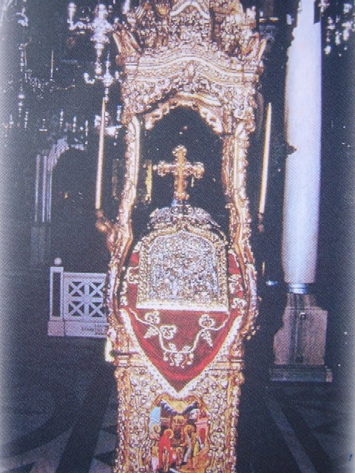
Fig. 3: The first shrine of the Holy Icon.
(Calendar 2006 of Panhellenic Holy Foundation of Evangelistria of Tinos)
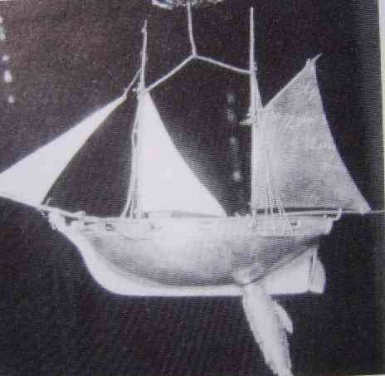
Fig. 4: The Ship with the fish, ‘Tama’ for a miracle.
Amiralis, George N., Tiniakes Antavgies. Istoria-Laografia (Tinos’ Shimmers. History -Laography)* (Athens: Tinos, 1996)

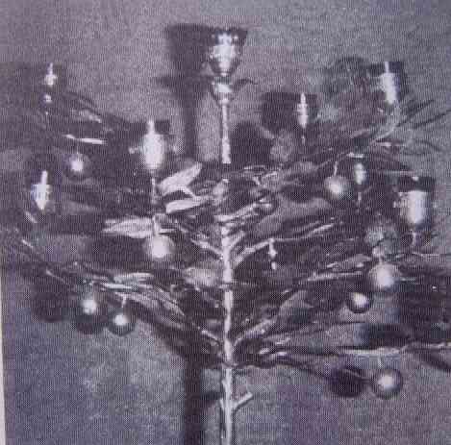
Fig. 5: Orange Tree, ‘Tama’ for a miracle
Amiralis, George N., Tiniakes Antavgies. Istoria-Laografia (Tinos’ Shimmers. History -Laography)* (Athens: Tinos, 1996)

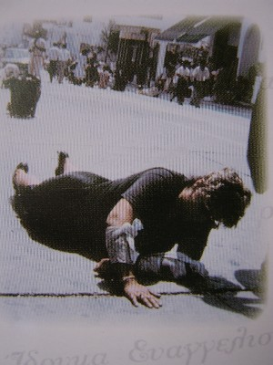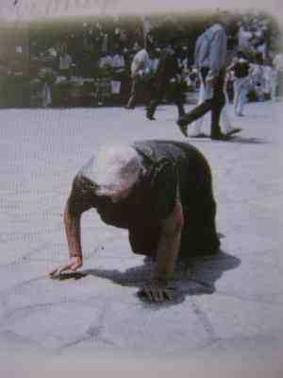
Fig. 6: Pilgrims performing ‘Tama’
(Calendar 2006 of Panhellenic Holy Foundation of Evangelistria of Tinos)

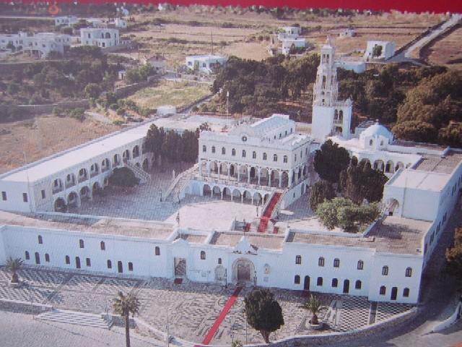
Fig. 7: The main church of Evangelismos in Tinos and surroundings
(Calendar 2006 of Panhellenic Holy Foundation of Evangelistria of Tinos)

Pearce, Susan M., 1992.
Pearce, 1992.
Pearce, 1992.
Pearce, Susan M, 1998.
Hoskins, Janet, 1998.
Kopytoff, Igor, 1986.
Kenna, Margaret E., 1984.
Kenna, 1984.
Panellenk Holy Foundation of Evangelistiria of Tinos (PHFET), 2006. Florakis, Alekos E., 2001.
McLees, Mother Nectaria, 2002.
Florakis, Alekos E., 2001.
McLees, 2002.
PHFET, 2006. Dubisch, Jill, 2000.
Mpourdakos, George Gr., 2004.
Mpourdakos, 2004.
Mpourdakos, 2004.
Amiralis, George N., 1996.
Dubisch, 2000.
PHFET, 2006.
the foundation that manages the church
These words are referred by Evangelist Lucas
Tiga, Theodoros K., 1967.
McLees, 2002.
PHFET, 2006.
McLees, 2002.
as the church’s records and commandant of the island’s report on Tuesday 20 December, 1842.
McLees, 2002. PHFET, 2006.
Florakis, Alekos E., 2001.
Dubisch, 2000.
Mpourdakos, 2004.
a greek word, plural of tama, used when people make promises with God in order to get their prayers answered.
Dubisch, 2000. McLees, 2002.
Dubisch, 2000. McLees, 2002.
McLees, 2002. PHFET, 2006.
Dubisch, 2000.
the church which is dedicated to the finding (i.e. ‘evresi’ in Greek language) of the Holy Icon.
Mpourdakos, 2004.
Florakis, Alekos E., 2004.
Dubisch, 2000.
PHFET, 2006.
Dubisch, 2000.
Dubisch, 2000.
Dubisch, 2000.
Michalopoulou, Thani, 1998.
Florakis, 2004. Dubisch, 2000. PHFET, 2006. Mpourdakos, 2004.
Florakis, 2004.
Mpourdakos, 2004.
Florakis, 2004. Florakis, Alekos E., 2001. Dubisch, 2000.
PHFET, 2006.
Dubisch, 2000.
Dubisch, 2000.
PHFET,2006.
Florakis, 2004.
Florakis, 2004.
PHFET, 2006. Chariati, Irini, 2002. Florakis, 2004. Linardos, Petros N. & Delatolas, Stefanos N., 2002.
Sofianos, Dimitrios Z., 2002.
Florakis, 2004.
Florakis, Alekos E., 2001.

